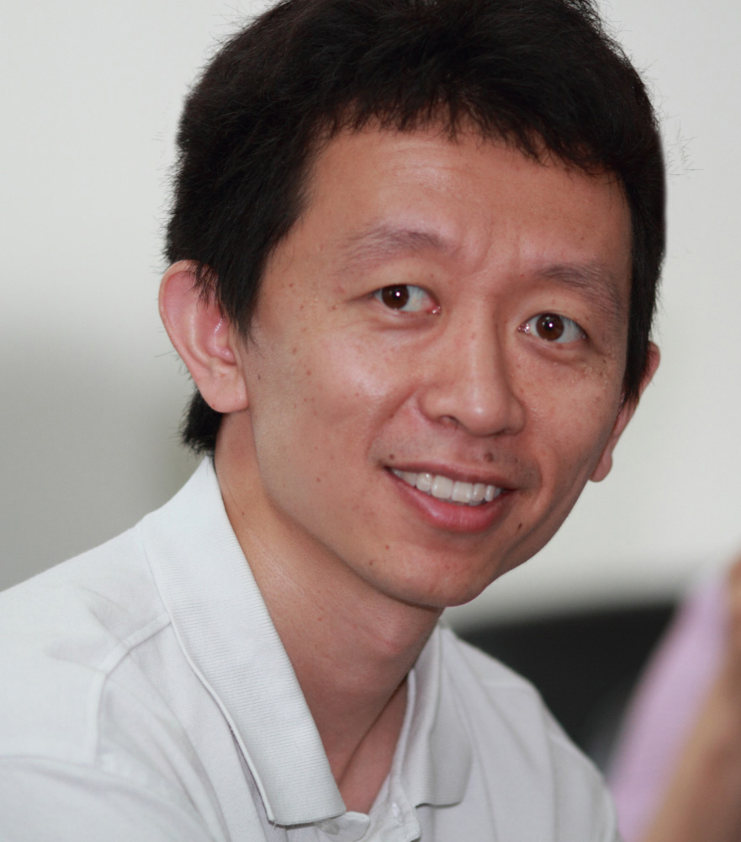

颉伟 研究员

青年千人，求是杰出青年学者，HHMI国际研究学者

1999-2003年，北京大学生命科学学院 生物科学 学士
2003-2008年，美国加州大学洛杉矶分校 分子生物学 博士
2006-2008年，美国加州大学洛杉矶分校 统计学 硕士
2008-2009年，美国加州大学洛杉矶分校 博士后
2009-2013年，美国圣地亚哥Ludwig肿瘤研究所，加州大学圣地亚哥分校 博士后
2013年-， 清华大学生命科学学院 研究员

主要科研领域与方向: 研究兴趣包括表观遗传学，基因组学和发育生物学。同时利用分子生物学、发育生物学和计算生物学的方法，采用干湿实验结合的方式，研究干细胞分化和个体发育以及人类疾病中的表观遗传调控机制。本实验室将致力于：（1）动物胚胎早期发育过程中的表观遗传调控；（2）干细胞分化过程中的表观遗传调控；（3）调控序列如启动子、增强子、绝缘子以及三维基因组在发育和细胞命运决定过程中的功能；（4）表观遗传相关人类疾病的调控机理。

代表性论文:
# Correspondence author
* First author

- Bingjie Zhang* Xiaotong Wu,* Wenhao Zhang,* Weimin Shen, Qingrui Sun, Kaili Liu, Yu Zhang, Qiujun Wang, Yuanyuan Li, Anming Meng,# Wei Xie# (2018) Widespread enhancer dememorization and promoter priming during parental-to-zygotic transition. Molecular Cell 72 (673-686).
- Jingyi Wu,* Jiawei Xu,* Bofeng Liu,* Guidong Yao,* Peizhe Wang,* Zili Lin,* Bo Huang, Xuepeng Wang, Tong Li, Senlin Shi, Nan Zhang, Fuyu Duan, Jia Ming, Xiangyang Zhang, Wenbin Niu, Wenyan Song, Haixia Jin, Yihong Guo, Shanjun Dai, Linli Hu, Lanlan Fang, Qiujun Wang, Yuanyuan Li, Wei Li, Jie Na,# Wei Xie# & Yingpu Sun# (2018) Chromatin analysis in human early development reveals epigenetic transition during ZGA. Nature 557 (256–260).
- Qianhua Xu, Wei Xie# (2018) Epigenome in Early Mammalian Development: Inheritance, Reprogramming and Establishment. Trends in Cell Biology 28 (3).
- Yuanyuan Li,* Hui Zheng,* Qiujun Wang, Chen Zhou, Lei Wei, Xuehui Liu, Wenhao Zhang, Yu Zhang, Zhenhai Du, Xiaowo Wang, Wei Xie# (2018) Genomewide analyses reveal a role of Polycomb in promoting hypomethylation of DNA methylation valley. Genome Biology 19 (18).
- Yu Zhang,* Yunlong Xiang,* Qiangzong Yin,* Zhenhai Du,* Xu Peng, Qiujun Wang, Miguel Fidalgo, Weikun Xia, Yuanyuan Li, Zhenao Zhao, Wenhao Zhang, Jing Ma, Feng Xu, Jianlong Wang, Lei Li, Wei Xie# (2018) Dynamic epigenomic landscapes during early lineage specification. Nature Genetics 50 (96-105).
- Zhenhai Du, Hui Zheng, Bo Huang, Rui Ma, Jingyi Wu, Xianglin Zhang, Jing He, Yunlong Xiang, Qiujun Wang, Yuanyuan Li, Jing Ma, Xu Zhang, Ke Zhang, Michael Q. Zhang, Juntao Gao, Jesse R. Dixon, Xiaowo Wang, Jianyang Zeng, Wei Xie# (2017) Allelic reprogramming of 3D chromatin architecture during early mammalian development. Nature 547 (232-235).
- Yuwen Ke,* Yanan Xu,* Xuepeng Chen,* Songjie Feng,* Zhenbo Liu, Yaoyu Sun, Xuelong Yao, Fangzhen Li, Wei Zhu, Lei Gao, Haojie Chen, Zhenhai Du, Wei Xie, Xiaocui Xu, Xingxu Huang,# and Jiang Liu# (2017) 3D Chromatin Structures of Mature Gametes and Structural Reprogramming during Mammalian Embryogenesis. Cell 170 (357-381).
- Reinhard Brunmeir*, Jingyi Wu*, Xu Peng, Sun-Yee Kim, Sofi G. Julien, Qiongyi Zhang, Wei Xie# and Feng Xu# (2016) Comparative Transcriptomic and Epigenomic Analyses Reveal New Regulators of Murine Brown Adipogenesis. PLoS Genetics 12(12): e1006474.
- Wenhao Zhang,* Weikun Xia,* Qiujun Wang, Aaron Towers, Jiayu Chen, Rui Gao, Yu Zhang, Chia-an Yen, Ah Young Lee, Yuanyuan Li, Chen Zhou, Kaili Liu, Jing Zhang, Xiuqi Chen, Zai Chang, Danny Leung, Shaorong Gao, Yong-hui Jiang, Wei Xie# (2016) Isoform switch of TET1 regulates demethylation and mouse development. Molecular Cell 64 (1-12).
- Xiaozhe Xiong, Tatyana Panchenko, Shuang Yang, Shuai Zhao, Peiqiang Yan, Wenhao Zhang, Wei Xie, Yuanyuan Li, Yingming Zhao, C David Allis & Haitao Li (2016) Selective recognition of histone crotonylation by double PHD fingers of MOZ and DPF2. Nature Chemical Biology 12, (1111–1118).
- Bingjie Zhang,* Hui Zheng,* Bo Huang,* Wenzhi Li,* Yunlong Xiang, Xu Peng, Jia Ming, Xiaotong Wu, Yu Zhang, Qianhua Xu, Wenqiang Liu, Xiaochen Kou, Yanhong Zhao, Wenteng He, Chong Li, Bo Chen, Yuanyuan Li, Qiujun Wang, Jing Ma, Qiangzong Yin, Zai Chang, Kehkooi Kee, Anming Meng, Shaorong Gao, Feng Xu, Jie Na,# Wei Xie# (2016). Allelic reprogramming of the histone modification H3K4me3 in early mammalian development. Nature 537 (553-557).
- Hui Zheng,* Bo Huang,* Bingjie Zhang,* Yunlong Xiang, Zhenhai Du, Qiujun Wang, Yuanyuan Li, Jing Ma, Xu Peng, Zai Chang, Feng Xu, Wei Xie# (2016). Resetting epigenetic memory by reprogramming of histone modifications in mammals. Molecular Cell 63 (1066-1079).
- Jingyi Wu,* Bo Huang,* He Chen, Qiangzong Yin, Yang Liu, Yunlong Xiang, Bingjie Zhang, Bofeng Liu, Qiujun Wang, Weikun Xia, Wenzhi Li, Yuanyuan Li, Jing Ma, Xu Peng, Hui Zheng, Jia Ming, Wenhao Zhang, Jing Zhang, Geng Tian, Feng Xu, Zai Chang, Jie Na, Xuerui Yang, Wei Xie# (2016). The landscape of accessible chromatin in mammalian preimplantation embryos. Nature 534 (652-657).
- Bo Xia, Dali Han, Xingyu Lu, Zhaozhu Sun, Ankun Zhou, Qiangzong Yin, Hu Zeng, Menghao Liu, Xiang Jiang, Wei Xie, Chuan He & Chengqi Yi (2015). Bisulfite-free, base-resolution analysis of 5-formylcytosine at the genome scale. Nature Methods 12,1047–1050.
- Danny Leung*, Inkyung Jung*, Nisha Rajagopal*, Anthony Schmitt, Siddarth Selvaraj, Ah Young Lee, Chia-An Yen, Shin Lin, Yiing Lin, Yunjiang Qiu, Wei Xie, Feng Yue, Manoj Hariharan, Pradipta Ray, Samantha Kuan, Lee Edsall, Hongbo Yang, Neil C. Chi, Michael Q. Zhang, Joseph R. Ecker & Bing Ren (2015). Integrative analysis of haplotype-resolved epigenomes across human tissues. Nature 518, 350-354.
- Jesse R. Dixon*, Inkyung Jung*, Siddarth Selvaraj*, Yin Shen, Jessica E. Antosiewicz-Bourget, Ah Young Lee, Zhen Ye, Audrey Kim, Nisha Rajagopal, Wei Xie, Yarui Diao, Jing Liang, Huimin Zhao, Victor V. Lobanenkov, Joseph R. Ecker, James A. Thomson & Bing Ren (2015). Chromatin architecture reorganization during stem cell differentiation. Nature 518, 331-336.
- Wei Xie#, Bing Ren# (2013) Enhancing Pluripotency and Lineage Specification, Science 341:245-7
- Wei Xie, Matthew D. Schultz, Ryan Lister, Zhonggang Hou, Nisha Rajagopal, Pradipta Ray, John W. Whitaker, Shulan Tian, R. David Hawkins, Danny Leung, Hongbo Yang, Tao Wang, Ah Young Lee, Scott A. Swanson, Jiuchun Zhang, Yun Zhu, Audrey Kim, Joseph R. Nery, Mark A. Urich, Samantha Kuan, Chia-an Yen, Sarit Klugman, Pengzhi Yu, Kran Suknuntha, Nicholas E. Propson, Huaming Chen, Lee E. Edsall, Ulrich Wagner, Yan Li, Zhen Ye, Ashwinikumar Kulkarni, Zhenyu Xuan, Wen-Yu Chung, Neil C. Chi, Jessica E. Antosiewicz-Bourget, Igor Slukvin, Ron Stewart, Michael Q. Zhang, Wei Wang, James A. Thomson, Joseph R. Ecker, and Bing Ren (2013) Epigenomic Analysis of Multi-lineage Differentiation of Human Embryonic Stem Cells, Cell 153: 1134-1148).
- Wei Xie, Cathy L Barr, Audrey Kim, Feng Yue, Ah Young Lee, James Eubanks, Emma L Dempster and Bing Ren (2012) Base-resolution analyses of sequence and parent-of-origin dependent DNA methylation in the mouse genome, Cell 148: 816-831.
- Hao Wu, Volkan Coskun, Jifang Tao, Wei Xie, Weihong Ge, Kazuaki Yoshikawa, En Li, Yi Zhang and Yi Eve Sun (2010) Dnmt3a-Dependent Nonpromoter DNA Methylation Facilitates Transcription of Neurogenic Genes, Science 329 (5990): 444-448.
- Mark H. Chin, Mike J. Mason, Wei Xie, Stefano Volinia, Mike Singer, Cory Peterson, Gayane Ambartsumyan, Otaren Aimiuwu, Laura Richter, Jin Zhang, Ivan Khvorostov, Vanessa Ott, Michael Grunstein, Neta Lavon, Nissim Benvenisty, Carlo M. Croce, Amander T. Clark, Tim Baxter, April D. Pyle, Mike A. Teitell, Matteo Pelegrini, Kathrin Plath and William E. Lowry (2009) Induced Pluripotent Stem Cells and Embryonic Stem Cells Are Distinguished by Gene Expression Signatures, Cell Stem Cell 5(1): 111-123.
- Wei Xie, Chunying Song, Nicolas L. Young, Adam Sperling, Feng Xu, Rupa Sridharan, Anne Conway, Benjamin A. Garcia, Kathrin Plath, Amander Clark and Michael Grunstein (2009) Histone H3 lysine 56 acetylation is linked to the core transcriptional network in human embryonic stem cells, Molecular Cell, 33(4):417-427.
- Roberto Ferrari, Matteo Pellegrini, Gregory A. Horwitz, Wei Xie, Arnold J. Berk and Siavash K. Kurdistani (2008) Epigenetic reprogramming by adenovirus e1a, Science 321, 1086-1088.
- Nimet Maherali*, Rupa Sridharan*, Wei Xie, Jochen Utikal, Sarah Eminli, Katrin Arnold, Matthias Stadtfeld, Robin Yachechko, Jason Tchieu, Rudolf Jaenisch, Kathrin Plath and Konrad Hochedlinger (2007) Directly reprogrammed fibroblasts show global epigenetic remodeling and widespread tissue contribution, Cell Stem Cell, 1(1): 55-70.
- Feng Xu, Qiongyi Zhang, Kangling Zhang, Wei Xie and Michael Grunstein (2007) Sir2 deacetylates histone H3 lysine 56 to regulate telomeric heterochromatin structure in yeast, Molecular Cell, 27(6): 890-900.

Contact：
Tel: +86-10-62771496 (Lab)
E-mail: xiewei121 AT tsinghua.edu.cn

